**Text for social media posts**

Recently used NHS Urgent and Emergency Care Services?

Lookout for the #UrgentandEmergencyCareSurvey arriving in the post soon. Your valuable feedback will help us improve the quality of our care and people’s experience.

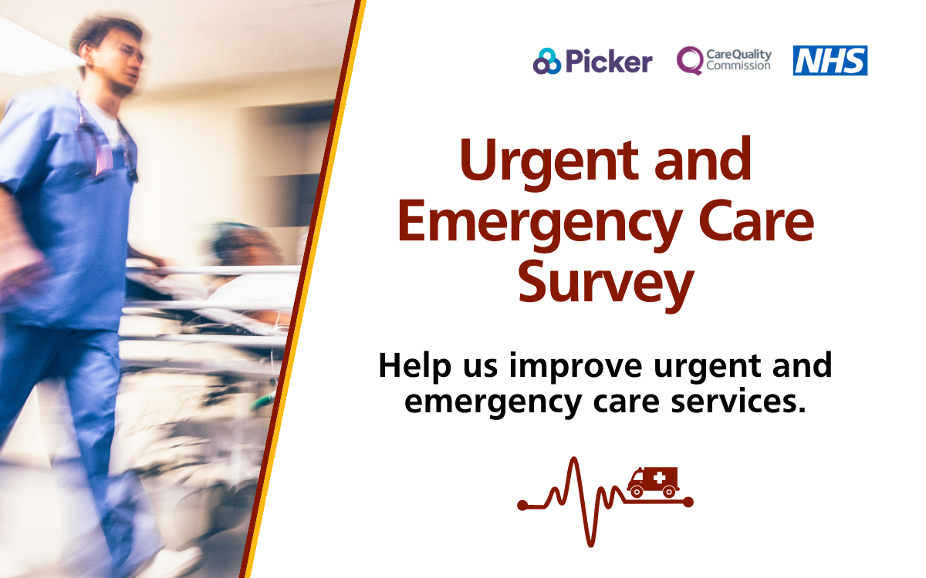

Social media card: Take action

Take the opportunity to make a difference to NHS Urgent and Emergency Care Services.

We’d love to hear about your experiences. The best way for us to improve your care is by hearing from people who have recently used our services.

#UrgentandEmergencyCareSurvey

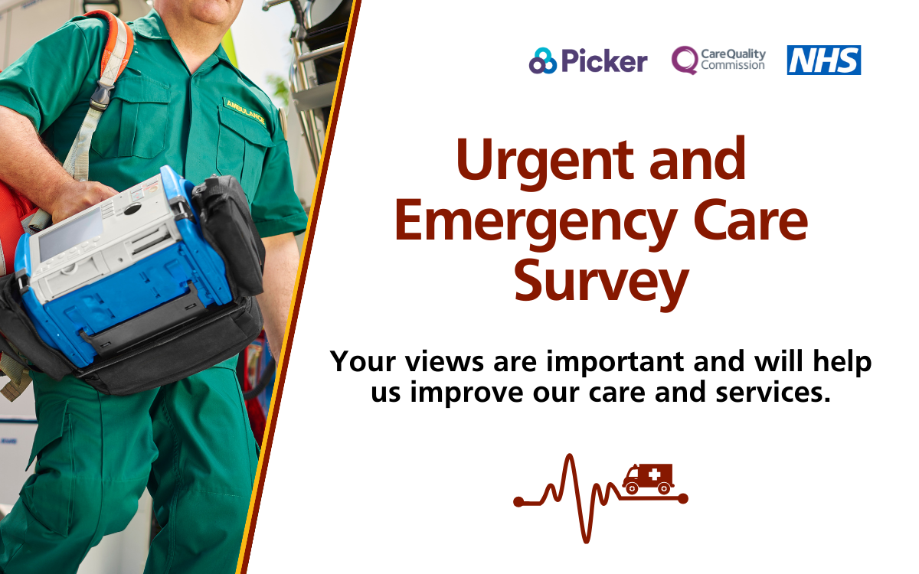

Social media card: Reminder One

Will you take a moment to share your experience of urgent and emergency care? Lookout for your #UrgentandEmergencyCareSurvey in the post!

Please take a moment to complete the survey and help us improve our care and services.

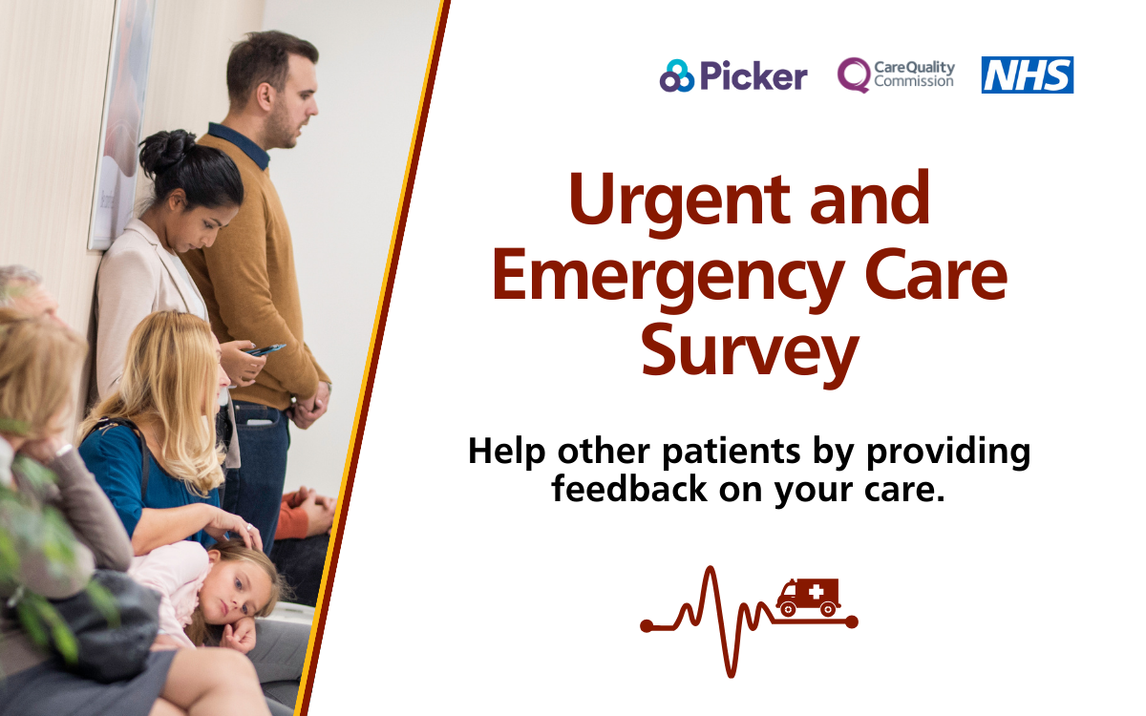

Social media card: Reminder Two

Recently used NHS Urgent and Emergency Care Services? This is your chance to give feedback on your care and treatment.

We are listening closely to what you have to say, your response will help us improve urgent and emergency care services for you.

#UrgentandEmergencyCareSurvey

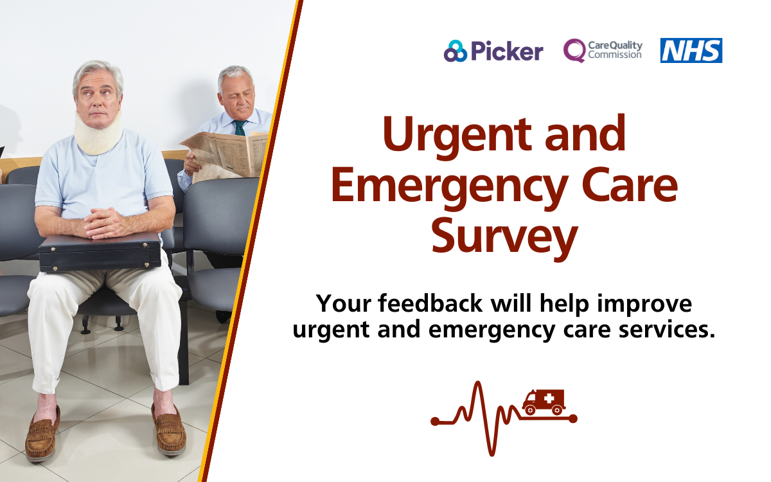

Social media card: Reminder Three